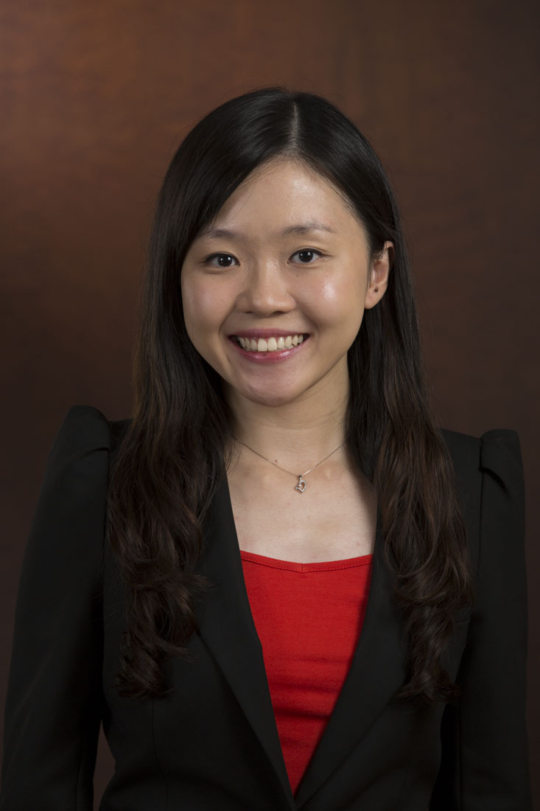**Wong Li Zhen**

Telephone No.: 9026 2230 Email: lizhenwong87@gmail.com

**EDUCATION**

**Chartered Accountant 2014**

ISCA, Singapore

**Chartered Financial Analyst Level 1 Jul 11**

CFA Institute, Singapore

**Bachelor of Accountancy (2nd Upper Honors) Jul 10**

Nanyang Business School

Nanyang Technological University, Singapore

**Diploma in Banking and Finance Service (Merit) May 07**

Singapore Polytechnic, Singapore

**WORK EXPERIENCE**

**UOB Bullion and Futures Ltd, Singapore**

**Assistant Vice President Mar 16 - Now**

**Manager Sep 14 – Feb 16**

* Manage financial accounts reconciliations and month end closing
* Prepare monthly consolidated management report with variance analysis
* Responsible of monthly GST reconciliation and quarterly submission
* Oversee treasury matters such as opening and maintaining of bank accounts
* Monitor daily regulatory requirements such as financial resources, total risk exposure, customer funds segregation and propose prompt remediation to management in the event of any breach
* In-charge of regulatory submission to MAS, SGX, ICE, IE Singapore and DGCX within prescribed timeline
* Actively involved in discussions and perform impact analysis on regulatory ratios or thresholds per new business initiatives
* Prepare quarterly maintenance margin threshold for management approval
* Review credit risk exposure of clients, counterparties and brokers
* Coordinate financial and regulatory audit processes with external auditors as well as internal compliance/assurance team
* Implement new accounting and risk systems in accordance to statutory requirements and reduce manual processes

**Orka Energy Pte Ltd, Singapore Aug 13 – Aug 14**

**Finance Manager**

* Performed full set accounting including AR, AP, GL, bank reconciliations, journals, intercompany transactions, GST registration and filing, corporate tax matters and etc.
* Reviewed monthly financials (in both IFRS and US GAAP) from overseas subsidiaries
* Executed Group financial consolidation in accordance to IFRS
* Managed year-end audit procedures and prepare statutory accounts for the Group
* Implemented timely cash flow projection and cash call from shareholders
* Pioneered and designed annual Group budget and forecasting process
* Initiated process improvements to ensure internal controls
* Performed analytical review on overseas project progression against budget and forecast
* Developed Group monthly management reports and project financial reports
* Participated in Group’s restructuring process, involving overseas taxation

**Singapore Power Group, Singapore (Management Associate Scheme / Scholarship Program)**

**(i) Assistant Manager, SP Training & Consultancy Company Jun 13 – Aug 13**

* Reviewed quarterly GST submission prepared by Accounts Executive
* Performed full set accounting including AR, AP, GL, journals
* Prepared monthly management report

**(ii) Assistant Manager, Settlement Division, Singapore Power Ltd Jun 11 – Jun 13**

* Executed month end closing / hedge accounting for derivatives, bonds, and FX contracts
* Being the champion in providing variance analysis across Singapore Power Group for complicated hedge relationships denominated in various currencies
* Monitored daily cash flow plotting to ensure optimal cash management
* Ensure compliance of daily counterparty limits and debt covenants
* Administered settlement of daily multicurrency transactions and principal/interest payments on Treasury transactions including loan and swap
* Managed movements in intercompany treasury transactions and loans
* Facilitated and in charge of annual financial budgeting and review
* Prepared monthly treasury reports to Head of Audit, CFO and GCEO
* Led all bank administration issues
* Delivered a savings of S$10K for spearheading Crystal Report in a Treasury system implementation across Singapore and Australia

**(iii) Accountant, Financial Control and Reporting**, **Singapore Power Ltd Feb 11 - Jun 11**

* Performed monthly analytical review on the financials for management reporting

**(iv) Accountant, Accounts and Tax Branch, SP Services Ltd Jun 10 - Feb 11**

* Responsible of cash portfolio - cash reconciliation and daily cash flow management
* Took charge of reviewing internal processes and identifying any control weaknesses
* Analyzed financial standing of potential vendors as part of the project decision making
* Gathered input from business units for half year financial review and budget exercise

**CO-CURRICULUM ACTIVITIES**

**Air Rifle Club, Nanyang Technological University, Singapore Aug 08 – Jul 09**

**President**

**Changi Youth Ambassador, Changi Airport Group, Singapore May 04 – May 07**

**Volunteer/Member**

**Air Rifle Club, Yishun Town Secondary School, Singapore Jan 00 – Dec 03**

**President**

**CAPABILITIES**

**Computer Skills**

* Microsoft Office (including Visual Basic), SAP Financial, UBIX, AAH, Optimai RBC System, Crystal Report, SunGard Quantum Treasury System, Business Planning & Consolidation (BPC), CTMS, SPSS, AccPac

**Languages**

* Fluent in English and Mandarin (Written and Spoken)